To reset your password, please follow the steps below:

Go to the log in page: https://ri-cranston.myfollett.com/aspen/logon.do

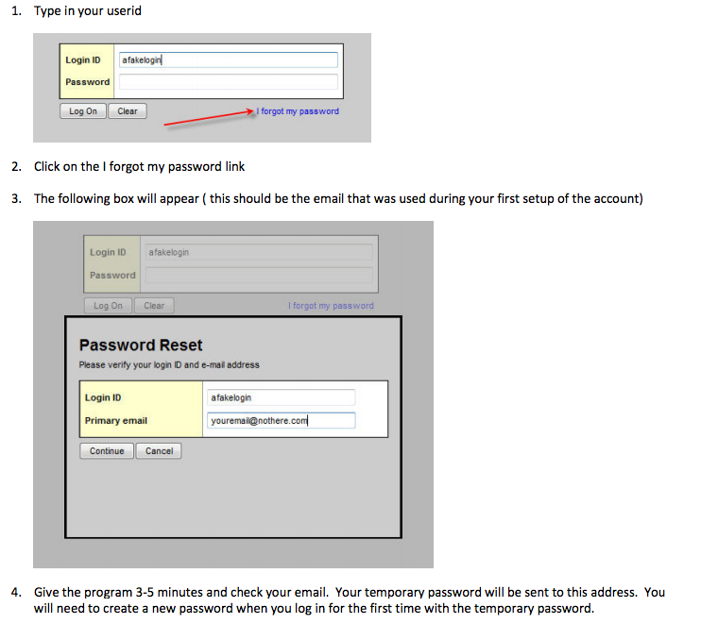

**Please read all of the boxes to follow the guide lines to reset!!!!

